3211 N. Roan St. Johnson City, TN 37601
(423) 979-2581 – Susan@arcd.org - www.ARCD.org

26th annual Regional Envirothon
Team Information Packet

Warriors Path State Park
490 Hemlock Rd
Kingsport, TN 37663
Wednesday, April 17, 2019
9:00am-1:00pm

The Envirothon is a unique outdoors environmental competition in which high school students demonstrate their knowledge of environmental science and natural resource management, and their ability to work together as a team.

Please take the time to completely fill out the required documents to register your team(s) for Envirothon. Receipt of all your students’ information and consent forms by Friday March 29, 2019 will ensure your team(s) preparation for competition. Questions? (423) 979-2581

All Study Materials and information about the State Envirothon and National Envirothon are online at TNRCD.org

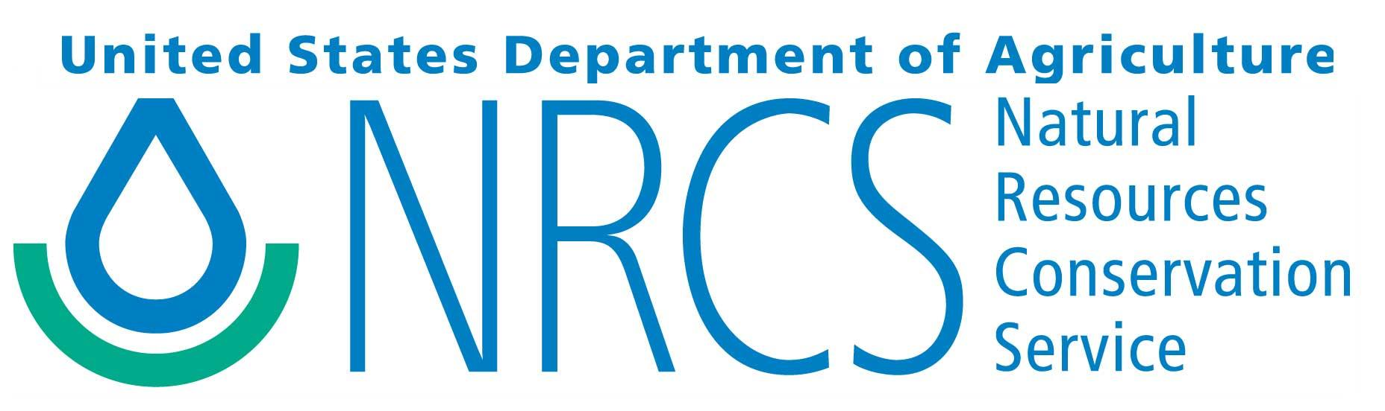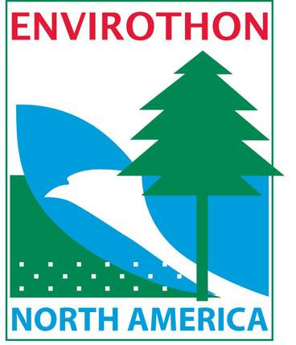
Appalachian Resource Conservation & Development Council
26th Regional Envirothon
Warriors Path State Park April 17, 2019
QUESTIONS?
Susan @ 423-979-2581 / Susan@gmail.com

2019 FEES:
$25.00 for all teams.

Each school can register 2 teams to represent the school. Additionally, a county Soil Conservation Youth Board may be represented by a team, and a homeschool group may sponsor 2 teams.

1st Step: REGISTER ONLINE -

1) Go online to register teams: www.arcd.org/envirothon

2nd Step: MAIL IN -

2) Mail in check to payable to Appalachian RC&D Council

3rd Step: PREPARE

3) Study Materials: www. https://drive.google.com/drive/folders/1TXNLK72WSd3ZlnxebvCIcWL5LxHG8PKM

4) Prepare all signed parental consent forms.
Without a signed form, a student cannot participate!!

Register teams online by March 29, 2019

Appalachian RC&D Council
26th Regional Envirothon
See You There & Good Luck!!
Emergencies or need directions, call Susan’s Cell at 423-737-8768

Wednesday April 17, 2019
Warriors Path State Park
490 Hemlock Rd Kingsport, TN 37663

SCHEDULE

8:30 ... Arrive (Please arrive on time. Orientation will begin promptly).
9:00-9:15 … Orientation
9:30 – 10:45 ... Testing Stations (15 minutes per test-5 minutes Between Stations)
Wildlife, Forestry, Soils, Aquatic Ecology, Ag Soil and Water Conservation
9:30 - 9:45 ... Station # 1

9:50 - 10:05… Station # 2

10:10 - 10:20… Station # 3

10:25 - 10:40 … Station # 4

10:45 - 11:00… Station #5
11:00 - 11:45... Test Instructor Remarks/Special Programming
11:45 - 12:15... Lunch
12:15 - 12:45... Q&A and Awards

Consent & Release Form - FOR ALL STUDENT PARTICIPANTS

The undersigned parent(s) or guardian(s) or nearest of kin of (enter School’s Name) _______________________________________________________________ HIGH SCHOOL STUDENT (PRINT Name) ___________________________________________________, Date of Birth: ____________________(month/day/year), hereby AUTHORIZE his / her enrollment in THE APPALACHIAN RC&D COUNCIL ENVIROTHON PROGRAM ON APRIL 17, 2019, and represent
(a) That the child is in good physical condition and able to participate fully in all activities of the Program without adverse effects to himself / herself or any others participating in the Program.

I / We acknowledge that the activities of the Program have been fully explained to me, which may include, but are not limited to instruction and tutoring; trips by auto, bus and other forms of transportation; social and athletic activities, and I / We CONSENT to his / her participation in all activities of the Program.

I / We hereby RELEASE the Program, Appalachian RC&D Council and any of their agents, servants or employees from liability for any injuries or damages of any nature offered by the child or me / us by reason of his / her participation in the Program.

Should the child be injured or become ill while participating in the Program, I / We hereby AUTHORIZE the administration of such first aid and medical services to him / her as the circumstances require and hereby RELEASE the Program, Appalachian RC&D Council, and any of their agents, servants or employees from liability for any injuries or damages of any nature suffered by the child or me / us by reason of any first aid, medical or other services performed or not performed upon him / her.

I / We understand that the authorization and release hereby given can only be withdrawn in writing delivered to the: Appalachian RC&D Council Office, located at 3211 N. Roan St. Johnson City, TN 37601, (423) 979-2581.

(One signature required of parent or legal guardian)

Signature of Parent & Date

Print Name of Parent

Address

City ST ZIP

Emergency Contact Phone Number

In Kind Contribution Voucher for Coaches and Testers
Please submit at Envirothon on APRIL 17, 2019

DATE: _____________________________________

NAME: __________________________________________________________________________.

ADDRESS: ___________________________________________________________________________.

I __________________________________, certify that I donated ____________ hours of work to ENVIROTHON 2019 activities. I also certify that I am qualified to do the work performed.
_______________________________________ ____________________
(Signature) (Date)

If the hourly rate donated is above the minimum wage, I further certify that my special qualifications and value to the Council and ENVIROTHON 2019 as listed are correct.

SPECIAL QUALIFICATIONS OF DONOR:
DESCRIPTION OF WORK PERFORMED:

HOURLY RATE: $__________.

DONATED SERVICE TOTAL (hours x hourly rate) = $ ____________.

These services were performed in connection with ENVIROTHON 2019 and are an eligible cost to the project.

I have reviewed the above donated service and the value of the work performed; I approve this computation.

________________________________________________________________________________
Appalachian RC&D |  | Date

Appalachian Resource Conservation & Development Council
3211 N. Roan St. Johnson City, TN 37601
(423) 979-2581 / Susan@gmail.com

